Exercises
Complete the exercises assigned by your instructor by typing the required information below in the space provided, drawing a model and pasting it into this document, and/or creating a table and copying and pasting it into this document. Attach this document to the Lab 7 Assignment in Brightspace and submit the assignment in Brightspace.

- Draw a data design (ERD) that would track information recorded on the employee time card shown below. Determine needed entities, attributes, data types, primary and foreign keys, and relationships. Make assumptions where necessary.
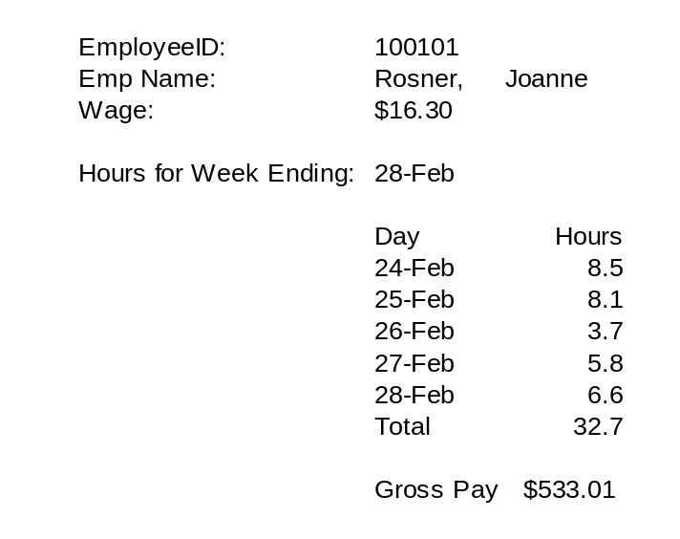
Answer: (copy and paste ERD)

- The table shown below is part of an office inventory database. Assume that Item ID is the primary key. Identify the design problems and draw a revised table structure that corrects those problems. Draw a well-designed ERD. Include entities, attributes, data types, primary and foreign keys, and relationships. Make assumptions where necessary.
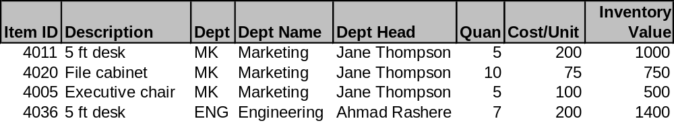
Answer: (Design Problems)

Corrected Table Structure:

Copy and paste ERD:

- Design the data for an upholstery shop database based on the order entry form below. Draw a well-designed ERD. Include entities, attributes, data types, primary and foreign keys, and relationships. Make assumptions where necessary.
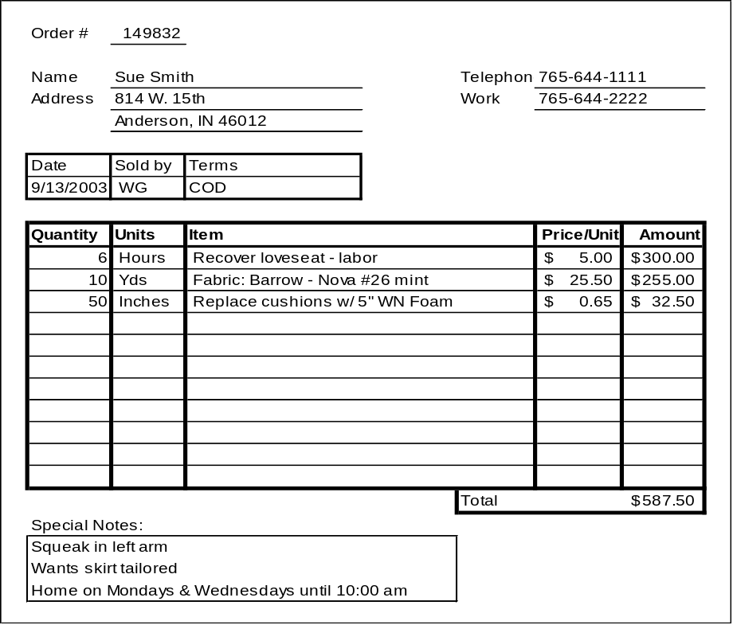
Answer: copy and paste ERD:

